Harrington Beautification
Brick Order Form
Dear Harrington Families & Staff: You can leave your legacy by buying a brick that will line the Harrington School walkway. Please review the diagrams below to ensure proper creation of your brick. Please see other form for choices of clip art. If you have any questions, please contact Leslie Zales at leslie.zales@gmail.com or 781-652-8669. Please return with check made payable to Harrington PTA Beautification (with Buy-A-Brick in the memo field) to the Hawks Hub by June 20, 2014.
4x8 brick with Text Only One, Two or Three Lines, 20 characters per line = $50.00
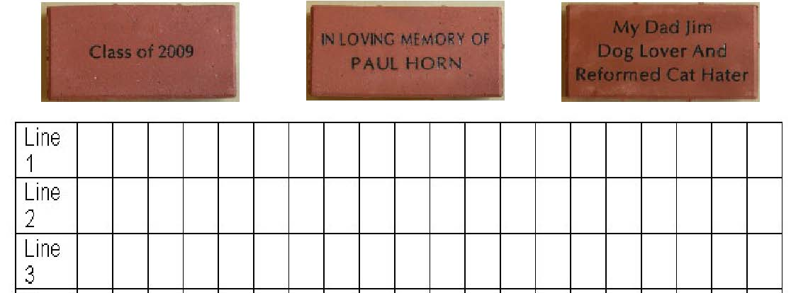
4x8 brick with Clip Art on Left 4x8 brick with Clip Art on Right = $55.00
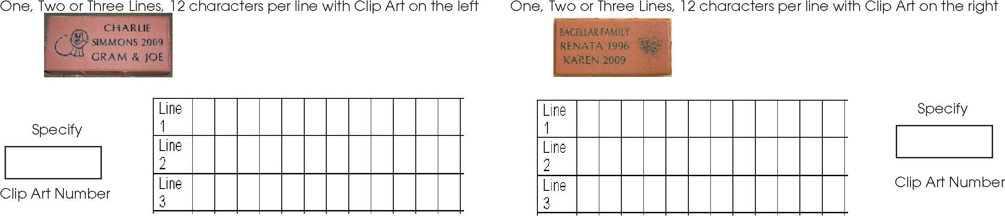
8x8 brick with Text Only Up to Six Lines, 20 characters per line = $100
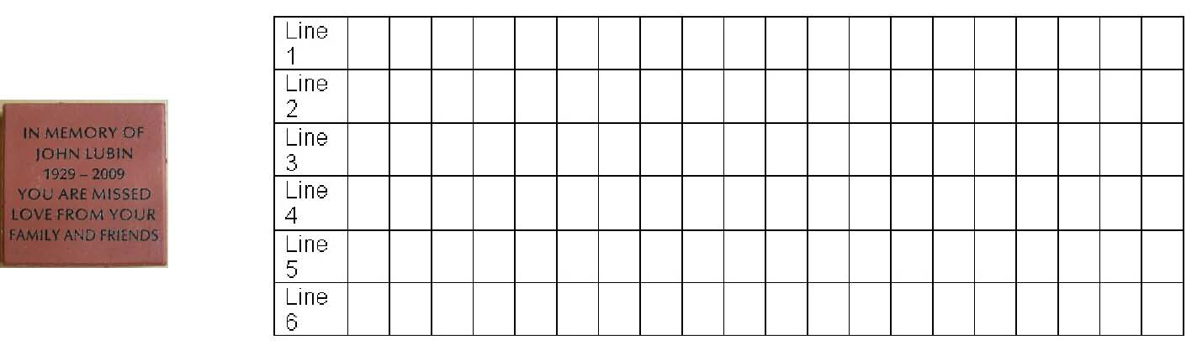
8x8 brick with Clip Art on Top or Bottom:
One, Two, Three or Four Lines, 20 characters per line with Clip Art on top or bottom = $105
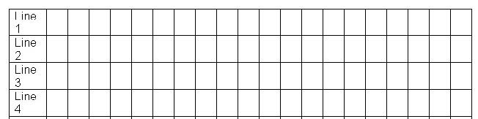 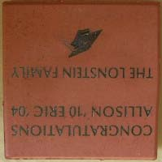 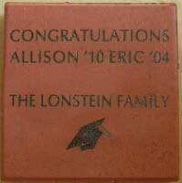 Specify Clip Art Number ____

Continued on other side…

